A000-ME-Isr-Eshelo Yabrudic culture-Homo Erectus-Acheulian-1.7 mya

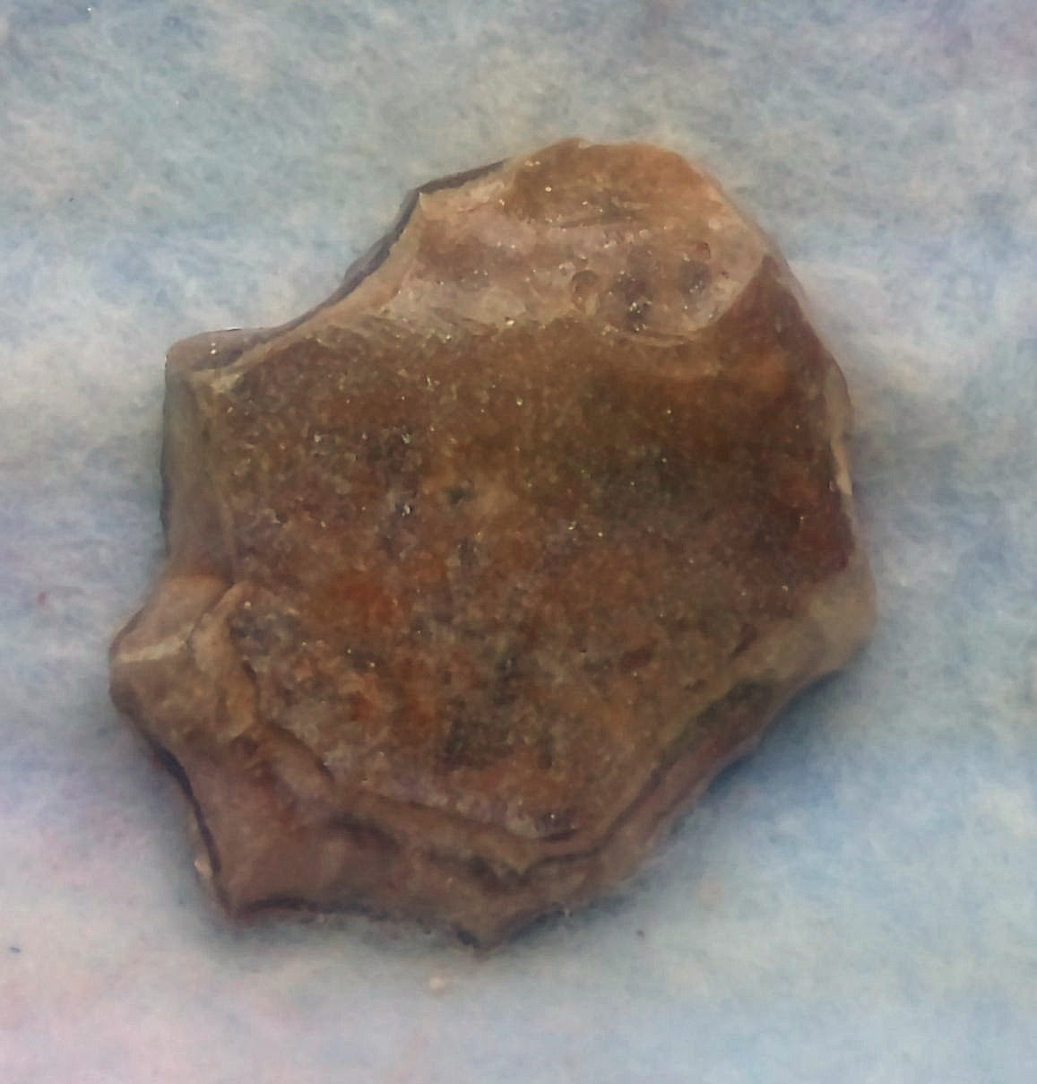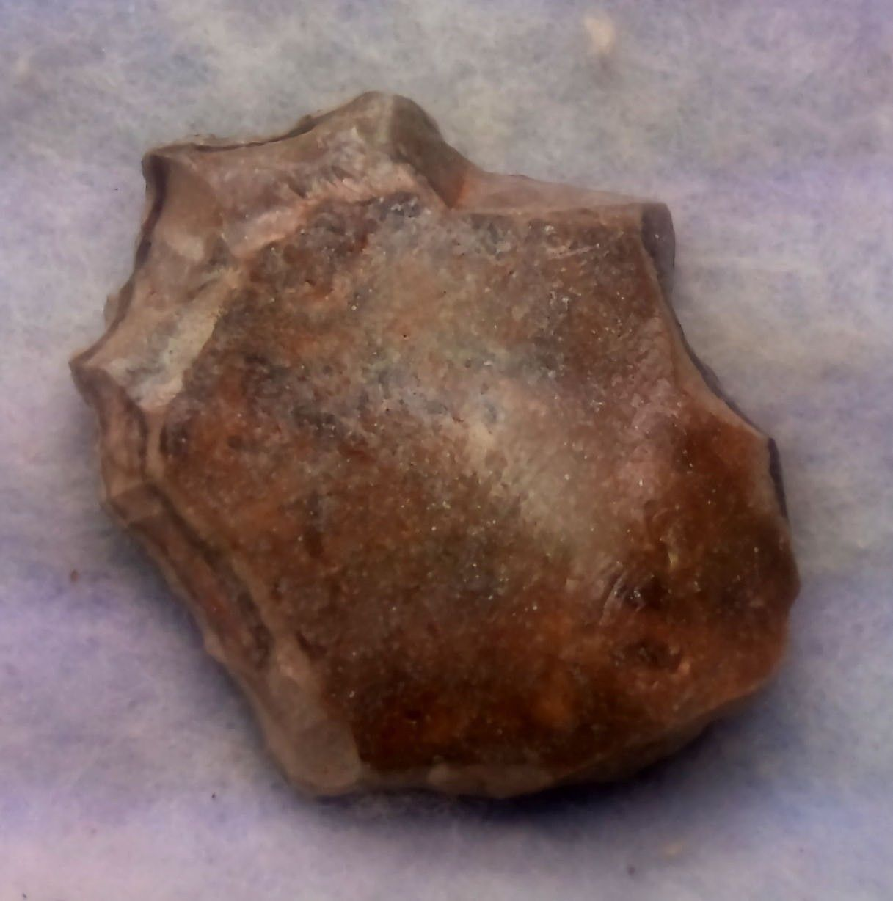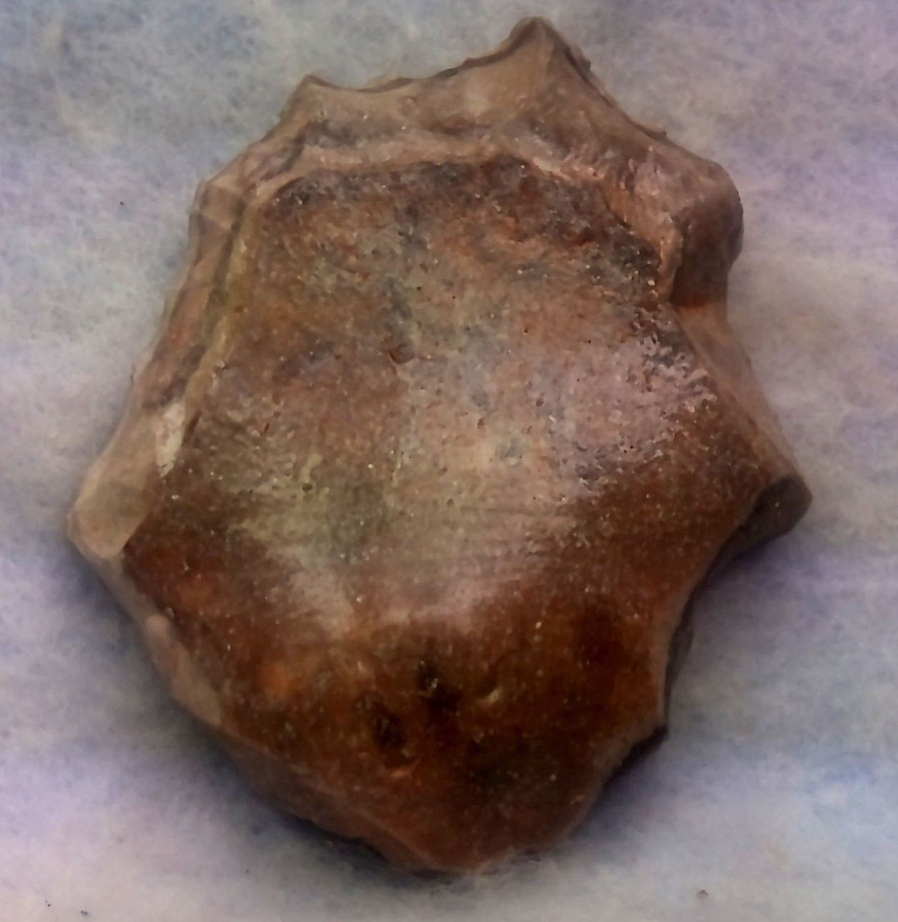 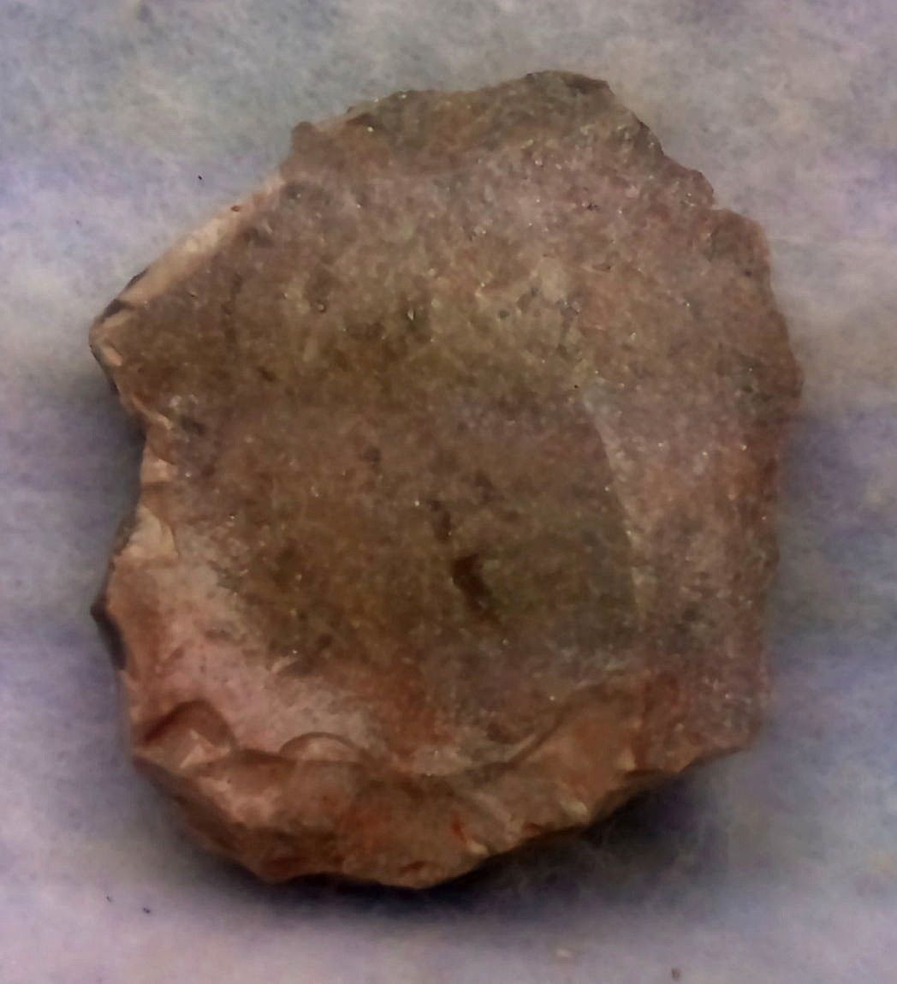

ME-Isr-Eshelo Yabrudic culture-Homo Erectus-Acheulian-1.7 mya

**Case No.: 1**

**Accession Number:**

**Formal Label:**

ME-Isr-Eshelo Yabrudic culture-Homo Erectus-Acheulian-1.7 mya

**Display Description:**

“An original archaeological find found in 2018 in official excavations along the Rift Valley in Israel. The finds were only chemically cleaned and coated with varnishes. According to the museum standard. Without any contact of work tools. No reconstruction work. Original cleaned only. Item sold legally. See detailed attachment. Please watch carefully the many pictures attached. The seller is a business owner in the Jordan Valley who provides various services to the teams of the archaeological excavations. Since the beginning of 2018, according to an official summary, part of the payment for the services is carried out in a "swap" deal against archeological findings for sale all over the world. I would like to cooperate with marketers around the world. Please contact anyone interested. The finds sold here were found in excavations from the Eilat region in the south along the Jordan Valley, the Dead Sea, Jericho, Beit Shean, the Golan Heights and Lebanon. Thank you for reading. MOSHE””

All findings are presented by me. Were found from the beginning of 2018 onwards. I provide various services to archaeological teams active along the Rift Valley. I set up a workshop for cleaning and coating varnishes for display. Some of the proceeds for the services are received in a valid and approved "swap" transaction. I negotiate and get my share before cleaning. I developed an ability to see and understand the quality of the cleaning findings, greater ability than any of the archaeologists' representatives. Therefore, I am able to receive special exhibits in return for which there is no chance that after the cleaning they would give them to me for sale. That's why you see here really special and rare items. I want to tell you a scientific subject, even though I am not a qualified archaeologist in training. There is no dispute that agriculture began in the world in the Jericho area. There is no dispute that the first city in the world was Jericho. And was also the first city in the world surrounded by a defensive wall. All of these came first to not with no reason, the correct answer to this is that the various residents in this area, were progressing more over tens or even hundreds of thousands of years. Of all the people of the world then. There is no mention in the archaeological literature of this claim I made. But the facts speak for themselves. Look at the stone tools from this area, which I am presenting. The general level is very high even in our times, there are pieces of stone art at a very high level, even today. Almost every vessel is decorated with art work on stone. And at a high level for at least the last hundred thousand years. Even their understanding then. The intense desire for decoration, all attest to high human intelligence. This also attests to the complexity and creativity of the stone works themselves. There are no doubt these prehistoric people from the various Stone Ages. In this area. Were much more intelligent than described in conventional literature.

And of course it brought them to be pioneers in agriculture and urban life. These only reinforce what I argued earlier. Look at the detailed images I present with each item. I make an effort to give you as much as possible the artistic aspect of the stones. I also have no doubt that these people had a much higher eye vision than we have today. We see many details on the items, only with a magnifier glass, or wile processing the images on the computer.  Even what is seen by eye, it is very difficult to produce these works with stone only with such precision and details. There is no doubt. They had very high eyesight. Like some hunting animals have. I don't see any one talking about this, and it is important. About population, the north area till Jericho and some 20 miles north. Was full with people in the Stone Age, they dig here and there, but one can see reminding almost any were. I say that this region was New York of the Stone Age on the Silk Road. Put my opinions in mind, I am right and know the rift valley Ander my foot.I deliberately do not give an opinion and evaluation of the period of the item, in order to avoid academic dispute, since all the parties are concerned with professional evaluation and not knowledge. In every case. The item is always about to write in the title and details. Beyond that everyone will appreciate in his personal opinion. MOSHE

**LC Classification:**

**Date or Time Horizon:**

**Geographical Area:**

**Map:**

**GPS Coordinates:**

**Cultural Affiliation:**

**Medium:**

**Dimensions**: L 1 5/8   
**Weight:**

**Provenance:**

**Condition:**

**Discussion:**

**References:**